# Table of Contents

**Table of Contents** **1**

**1. Introduction** **3**

1.1 Background 3

1.2 Scope and Motivation and Aim 3

1.3 Aim and Objectives 4

1.4 Software methodology 4

1.5 Measurable Organisational Value (MOV) 4

**2. Literature Review** **6**

2.1 Tic Tac Toe Brain game 6

2.2 React Native Tic-Tac-Toe (2018) - 王智永 7

2.3 Tic-tac-toe Collection - Oliver Brown 8

2.4 Tic-tac-toe Free - Optime Software 10

2.5 Tic Tac Toe Glow - Arclite Systems 11

2.6 Tic Tac Toe – 打井 12

2.7 Tic Tac Toe 13

2.8 MEGA Tic Tac Toe 14

2.9 Comparison Table 14

2.10 Literature Review Summary 15

**3. Software and Research Methodology** **16**

3.1 Software Methodology 16

3.2 Research Methodology 16

**4. Planning and Resources Required** **17**

4.1 Tools Required 17

4.1.1 React Native 17

4.1.2 Redux 17

4.1.3 Photoshop 17

4.1.4 MySQL 18

4.2 Planning Required 18

4.2.1 Allow user to register to our application 19

4.2.2 Allow Facebook and Gmail account to login 19

4.2.3 Allow player against human or friends in network environment 19

4.2.4 AI mode with different levels 19

4.2.4 Recording previous matching score 19

4.2.5 Support multiple languages 19

**5. Project Risk** **20**

5.1 Time Constraints 20

5.2 Lack of Experience 20

5.3 Stability 20

5.4 Performance 20

5.5 Data loss 20

5.6 Technology Change 20

**6. Gantt Chart** **21**

**7. Conclusion** **21**

**8. References** **22**

# 1. Introduction

## 1.1 Background

Tic tac toe game is a game for two players, the player take turns to place the X and O into the 3x3 grid. The player who first placed three of X or O in horizontal, or diagonal row wins the game. The game was played in the Roman Empire around the first century BC. At that time the game was called terni lapilli and the rules is different with tic tac toe game, each player only had three O or X , player need to continuous place and move the piece around the empty space, until one of the player placed three of pieces in horizontal, vertical or diagonal row to wins the game [1].

In 1952, a computer scientist Alexander S. Douglas at University of Cambridge developed the first tic tac toe video game. The game was played against the machine [2].

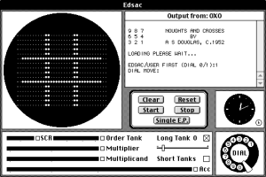

## 1.2 Scope and Motivation and Aim

The scope of this project is to design a game logic, using a hybrid programming language call React Native, to develop a friendly user interface mobile application. The benefit of using React Native it allow developer develop in IOS and android mobile application at the same time. It helps to reduce the develop time. For this project, we are planning to download the existing application from Apple and Google store, then we are going to identify the pros and cons by using this information to help us to develop our own application.

Our motivation is to develop a mobile application, it allows anyone can play this game in anytime anywhere they want. They is no age limit for user to download this application.

## 1.3 Aim and Objectives

Our aim is to allow user to use our mobile application to play with other human or against with computer. The objectives include

* Allow user to register to our application
* Allow FB and Gmail account to login
* Allow player match with another player in network environment
* AI mode (with different level)
* Recording previous matching score
* Support multiple languages
* Research on different features that could be added onto the application

## 1.4 Software methodology

Every software development must follow the software development life cycle (SDLC) method, this includes planning, analysis, design, implementation, testing and maintenance. The models we are use is agile method, the pros to using this method is easy to responding of any change of project requirements, it accepting any uncertainty when the project first start, which means more flexibly to make any decisions. The extreme programming is pair programming is suitable for two member team. This method allow us to keep on right track, since every one to two weeks, we need to show our progress to supervisors.

## 1.5 Measurable Organisational Value (MOV)

1.Identify the desire area of impact (Financial, Operation, Social, Strategic, Customer)

The measurable organisational value is target on the customer area, there is not age limit for user to using the application. In the future, we are planning to add more games into our mobile application, so the customer have more choose on our application. In financial side, we have used a hybrid programming language this allows we develop on IOS and Android mobile platform at the same time, this helps to reduce the time and the cost on the mobile application.

2.Identify the desire value of IT project (Better, faster, cheaper, do more )

For this project, we are planning to add more functionality to our mobile application, this will show the different between the exist application. The application is total free to download from the store.

3.develop an appropriate metric (Target increase or decrease Desire dollar % )

4. Set the time frame for achieving the MOV (KPIs)

For key performance indicator, we expect at least 2000 users are using our application by the end of 2018 and continuous increase 15% in each year.

5. Verify and get agreement from the project stakeholders (Agreement)

6. Summarize the MOV in a clear, concise statement of table

# 

# 2. Literature Review

There are a large variety of existing mobile applications and websites that design for Tic Tac Toe. All these applications have their own strengths and weaknesses and most of them designed for kids. Several of these applications have been carefully selected and listed.

## 2.1 Tic Tac Toe Brain game

The first application that has been chosen for review is called Tic Tac Toe Brain game, which is based on iOS platform and developed by Ayesha Yasser. There are versions for iPhone and iPad. This game has sleek layout, simple navigation and accessibility from App Store.

It is not an online game and you have to play with your friends alternatively on one iPhone or iPad. Of course, you can play the game with computer. You need not input and information before starting a game.

Another thing about this game which I have to mention is the annoying advertisements. There is a unmoved AD bar on the bottom of game screen. A full screen AD will pop up when you lose to computer.

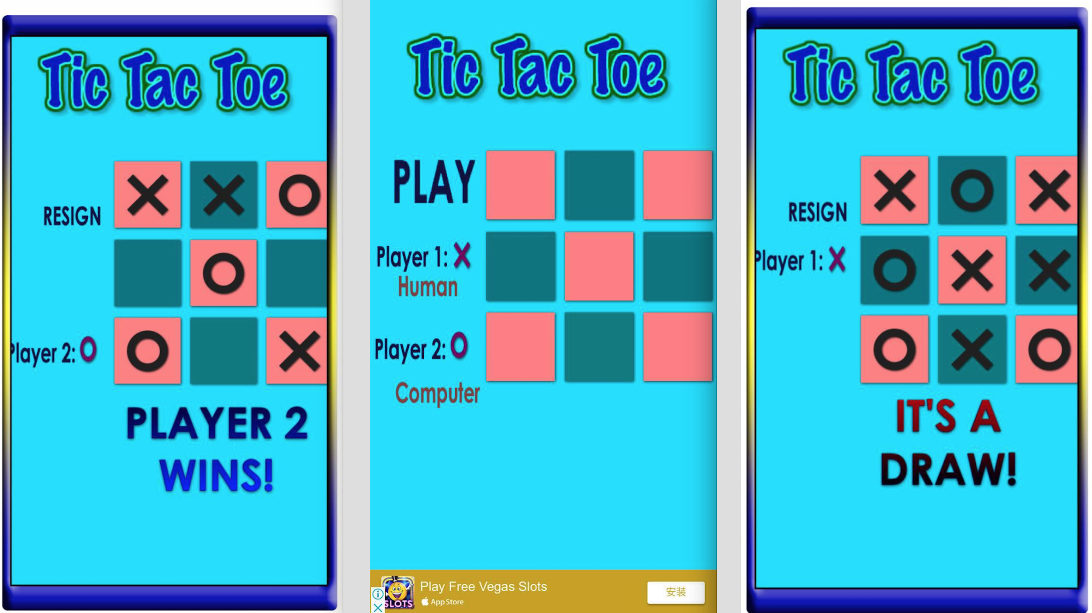

Fig. 2. (Tic Tac Toe Brain game, 2018)

## 2.2 React Native Tic-Tac-Toe (2018) - 王智永

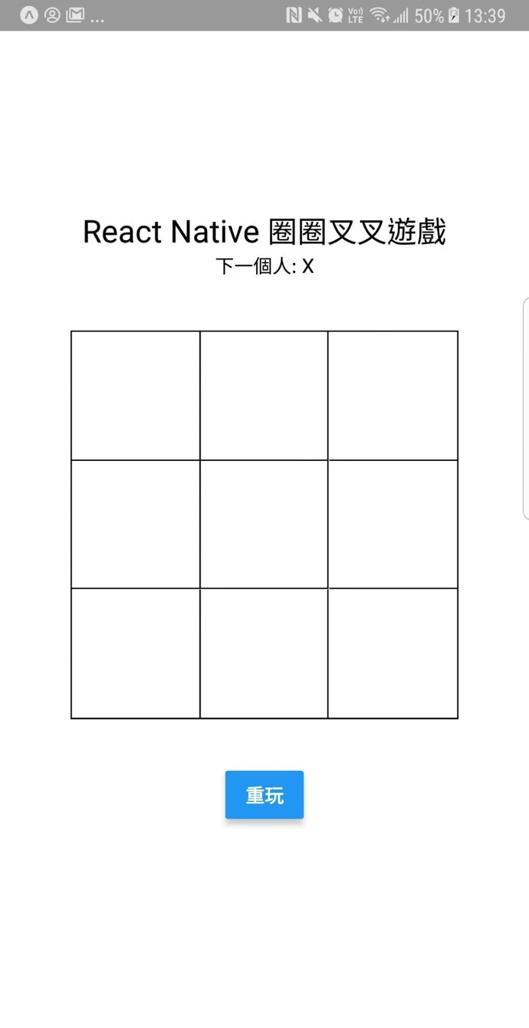

We have found a application, which used react native programming language to develop the Tic tac toe game. The react native Tic-Tac-Toe app is developed by 王智永, and is published in google store [3]. In this application, there is only one function, user only allow to against human, and both person need to using the same mobile device to play the game, that means you can not play through network environment and every time you placed the cross or noughts, you need to hand the mobile device to another player.

Also, the default language of this application is chinese, the application should provide other common languages as well. Since not everyone can understand chinese.

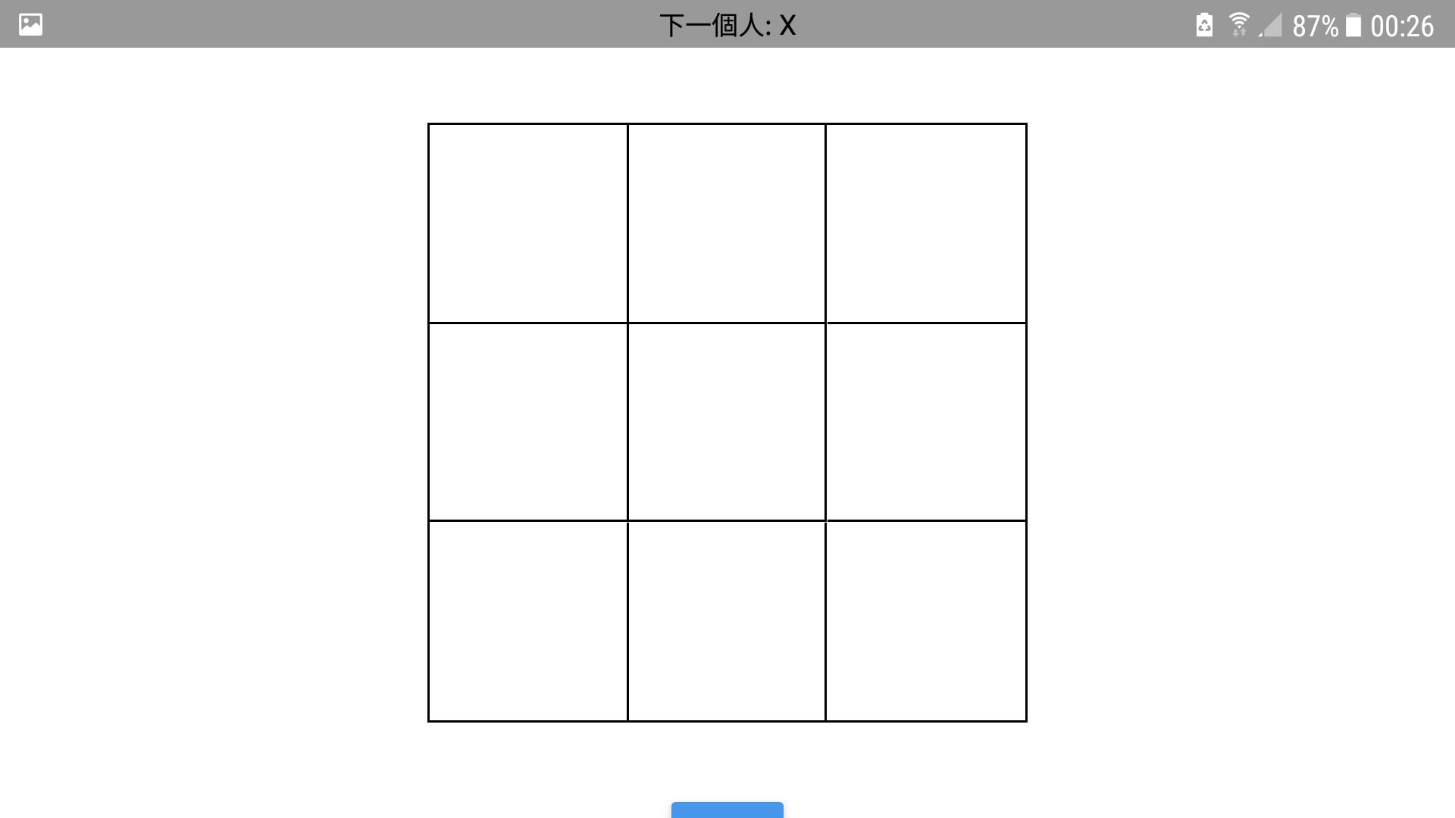

The above figure show the landscape mode, we have found one huge problem in this application, when we turn the phone in landscape mode, the user interface (UI) design it when wrong, the replay button is been cut off from the edge of screen, this make the button hard to click. Overall, the UI design and functionality is not that good.

## 2.3 Tic-tac-toe Collection - Oliver Brown

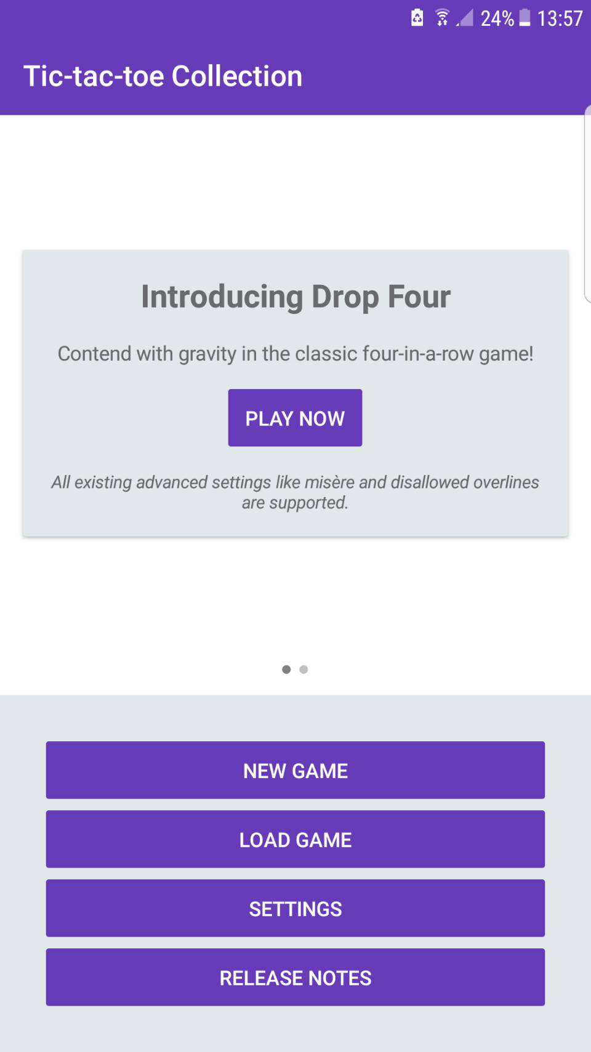

Tic tac toe collection is developed by Oliver Brown and is release at 5th January 2018. The developer is continuously adding more future into the application. The last updated is 19th May 2018. The application is available download from Google store. All the games allow to against local multiplayer with or without AI.

In the Home screen, there are four main functionality, this includes create a new game, load to previous save game, change the default settings and release notes.

In this application it has multiple games build in, this includes tic-tac-toe, gomoku and drop four game. As show in the figure below,

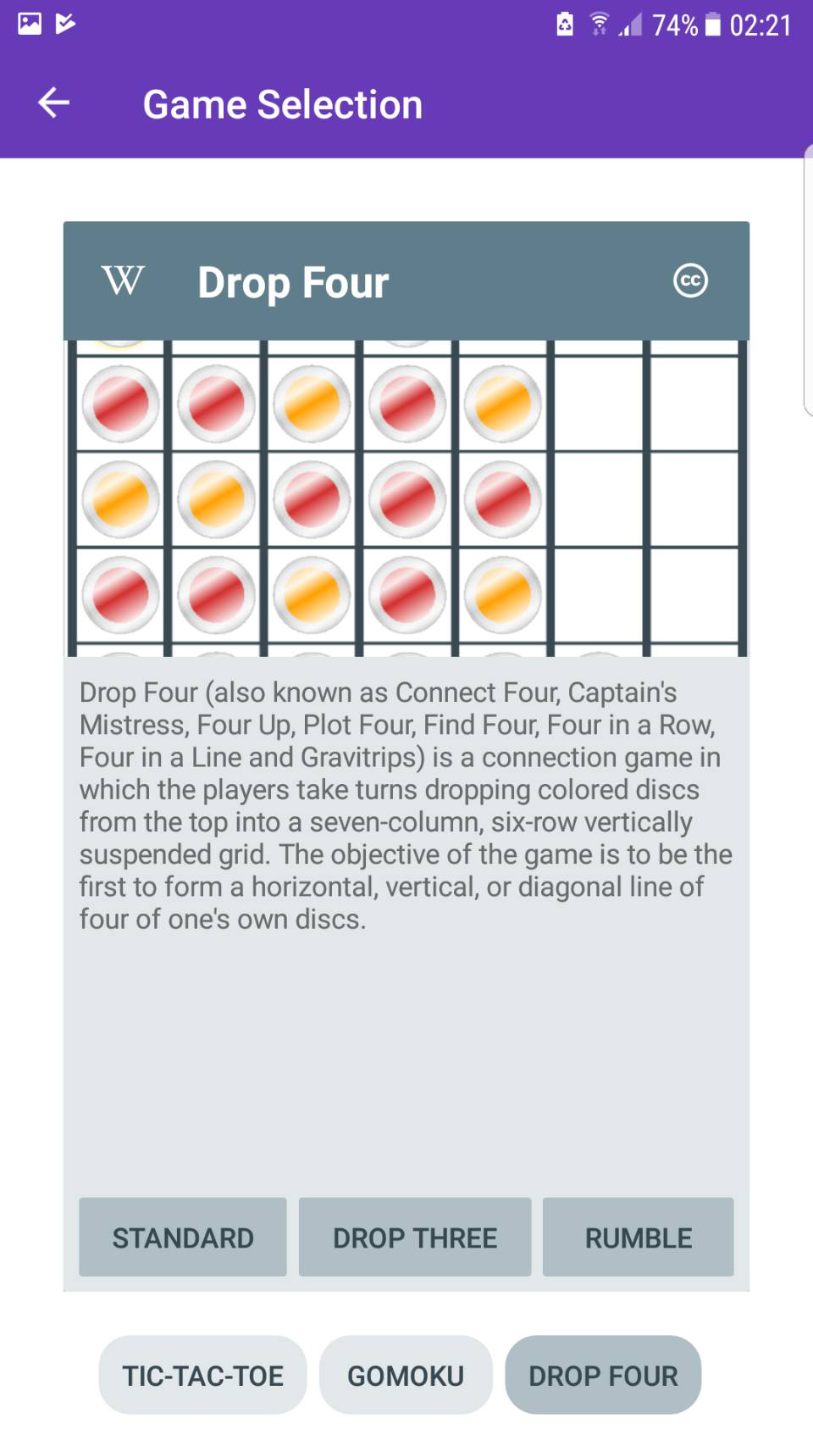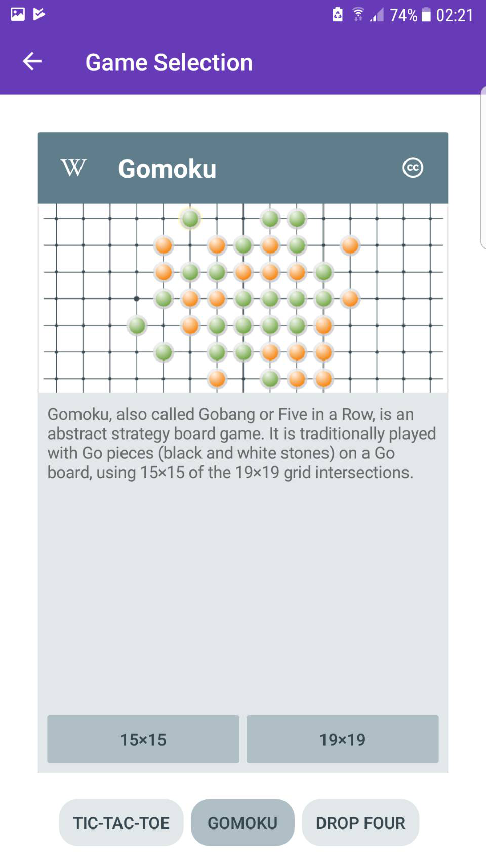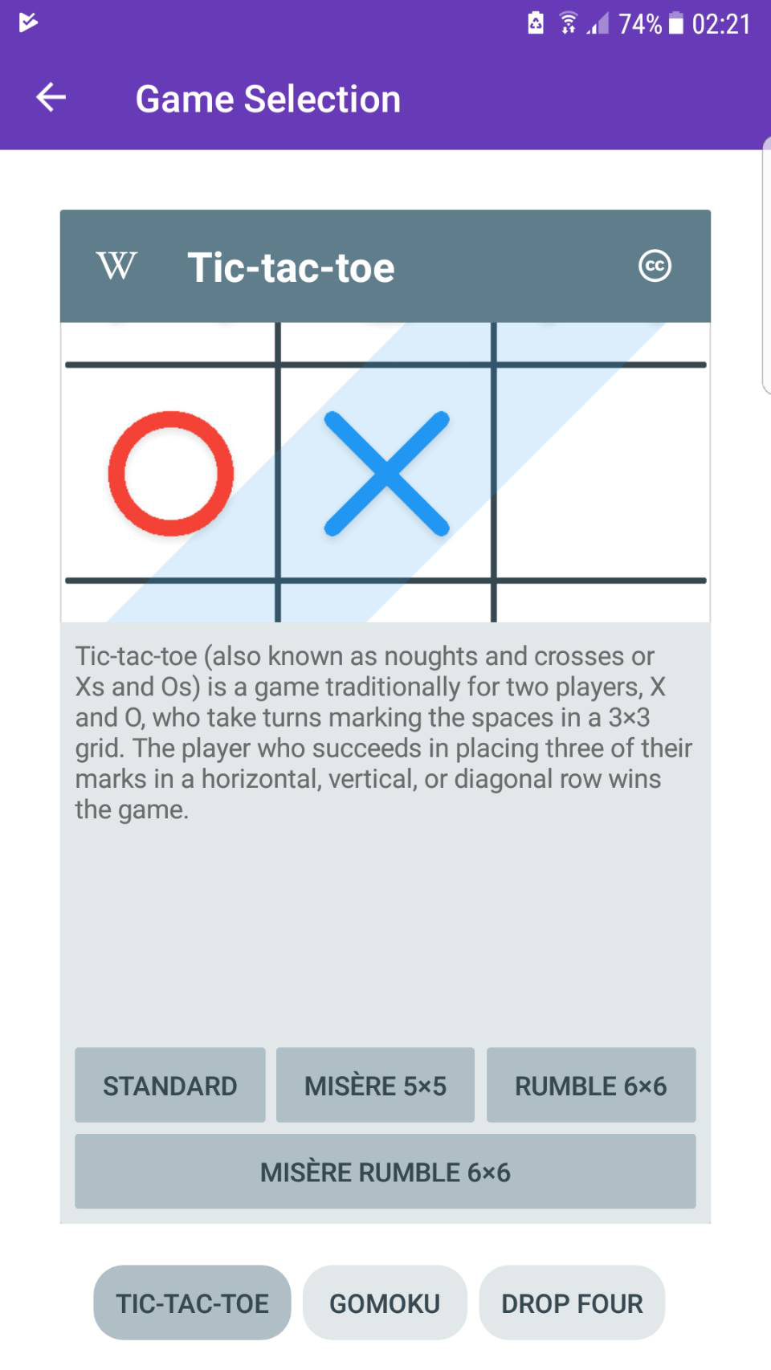

There are several options allow user to setup before the game start, this includes:

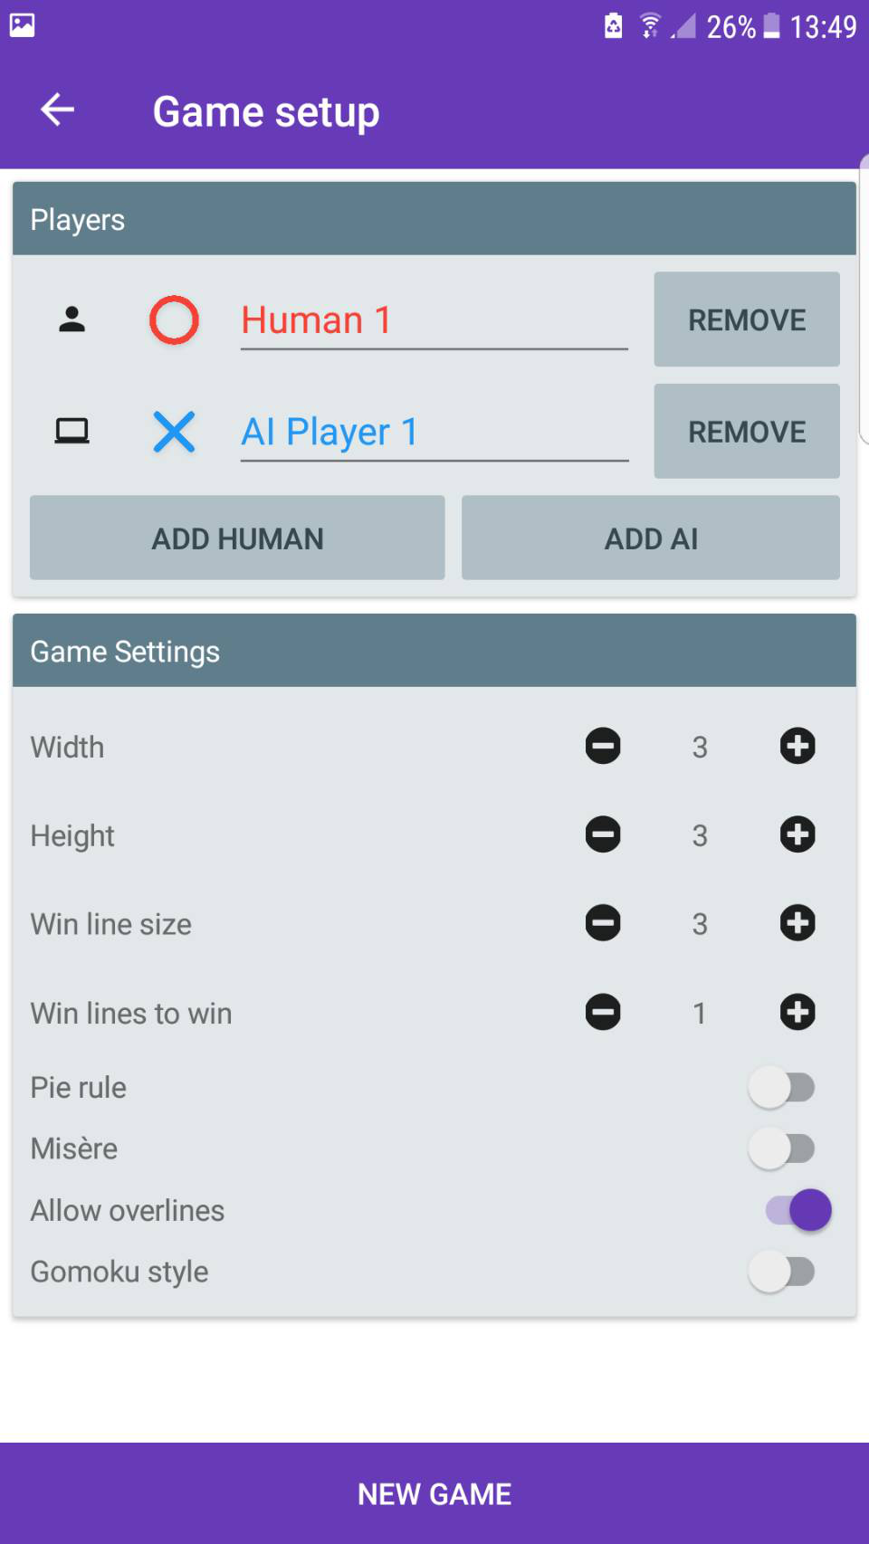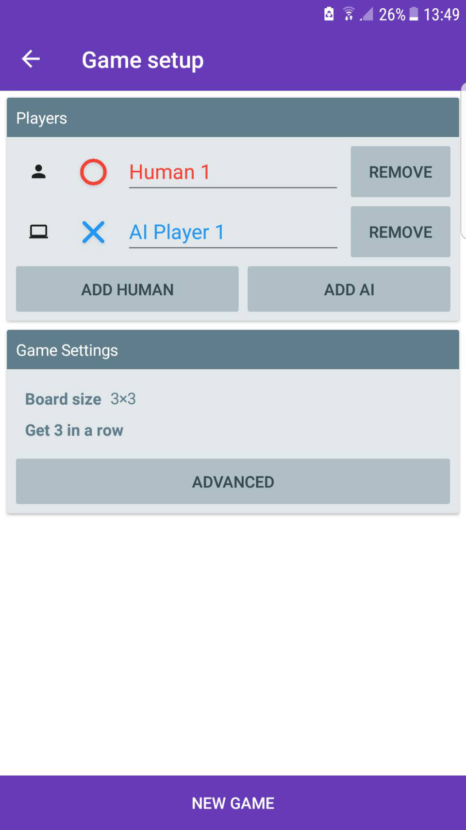

* Change the board size and game rule
* Allow to add or remove AI or human
* Allow to rename the AI or human

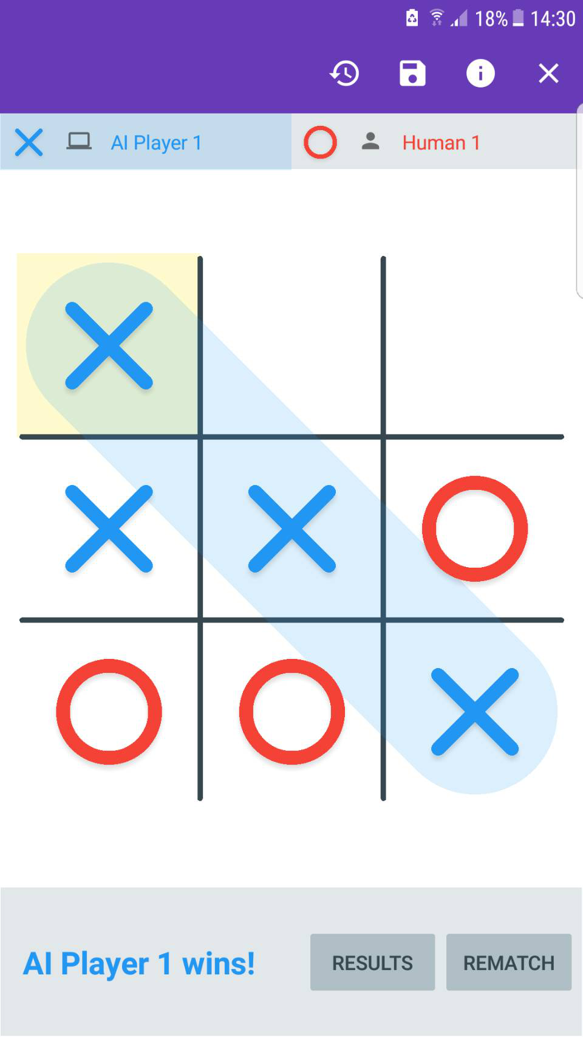

In the game layout, the user can do things include:

* Rewatch previous move state
* Save the game and resume later
* Exist game

After the game finished, the player can view the result or rematch the game. Overall, the application is good, but the one thing that i don’t like is the advertising keep popup and i have tested the application, when i want to add more than fourteen AIs or humans the application is crash.

## 2.4 Tic-tac-toe Free - Optime Software

The Tic-tac-toe Free application is developed by Optime Software organization, the player can against AI or friends [4]. The user interface design is pretty good. The application has 3.9 out of 5 score from Google store and more than ten million download times. From the below figure, we can see that in one player screen, the images is to small and hard to see. The pros of this application is player can select the game level they want to against with in the AI mode and can change the player name.

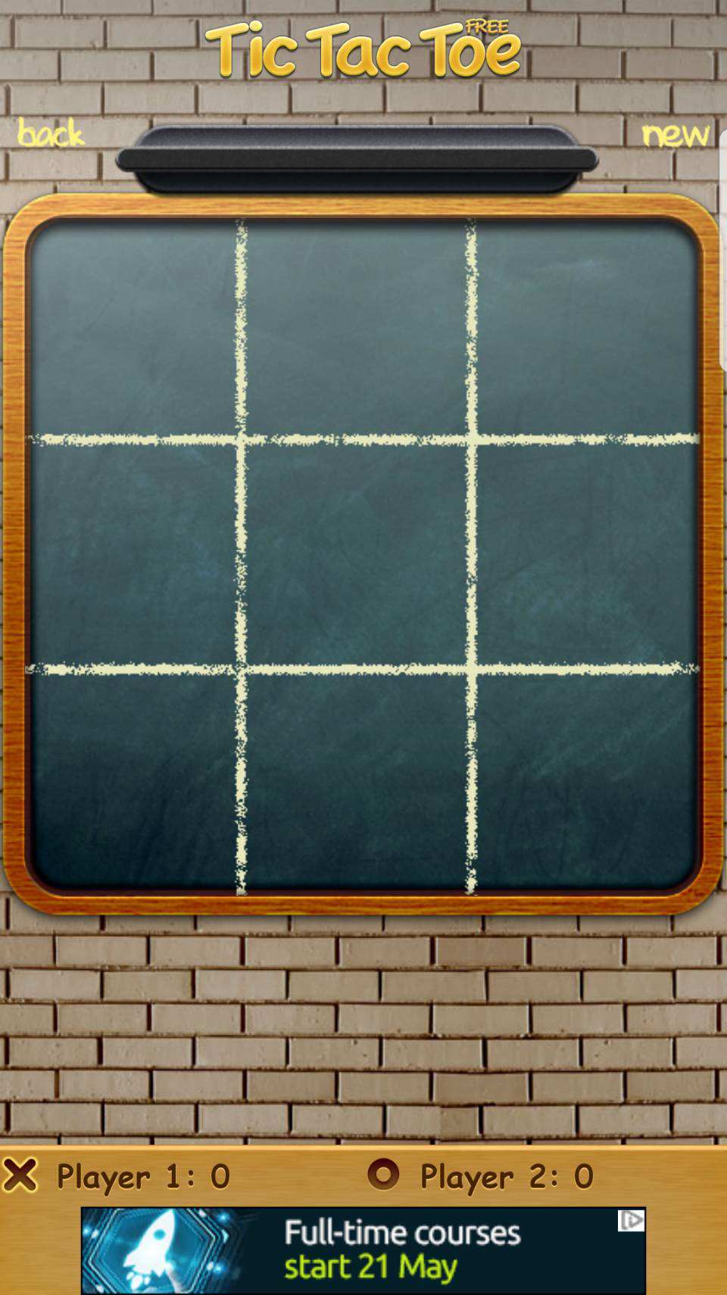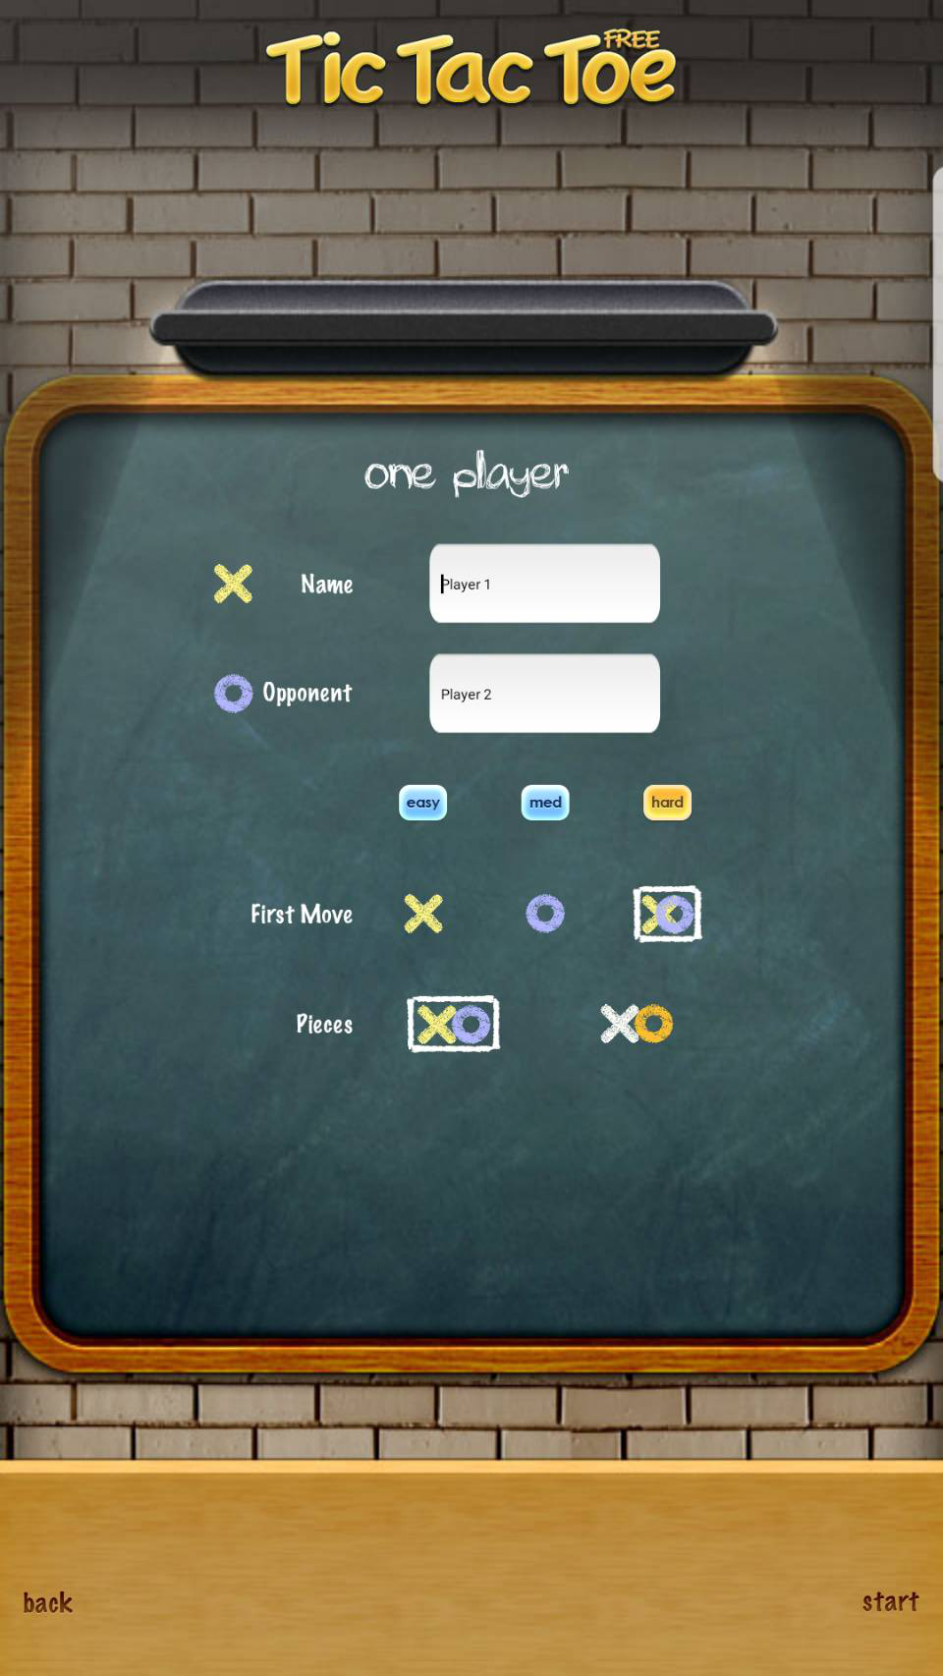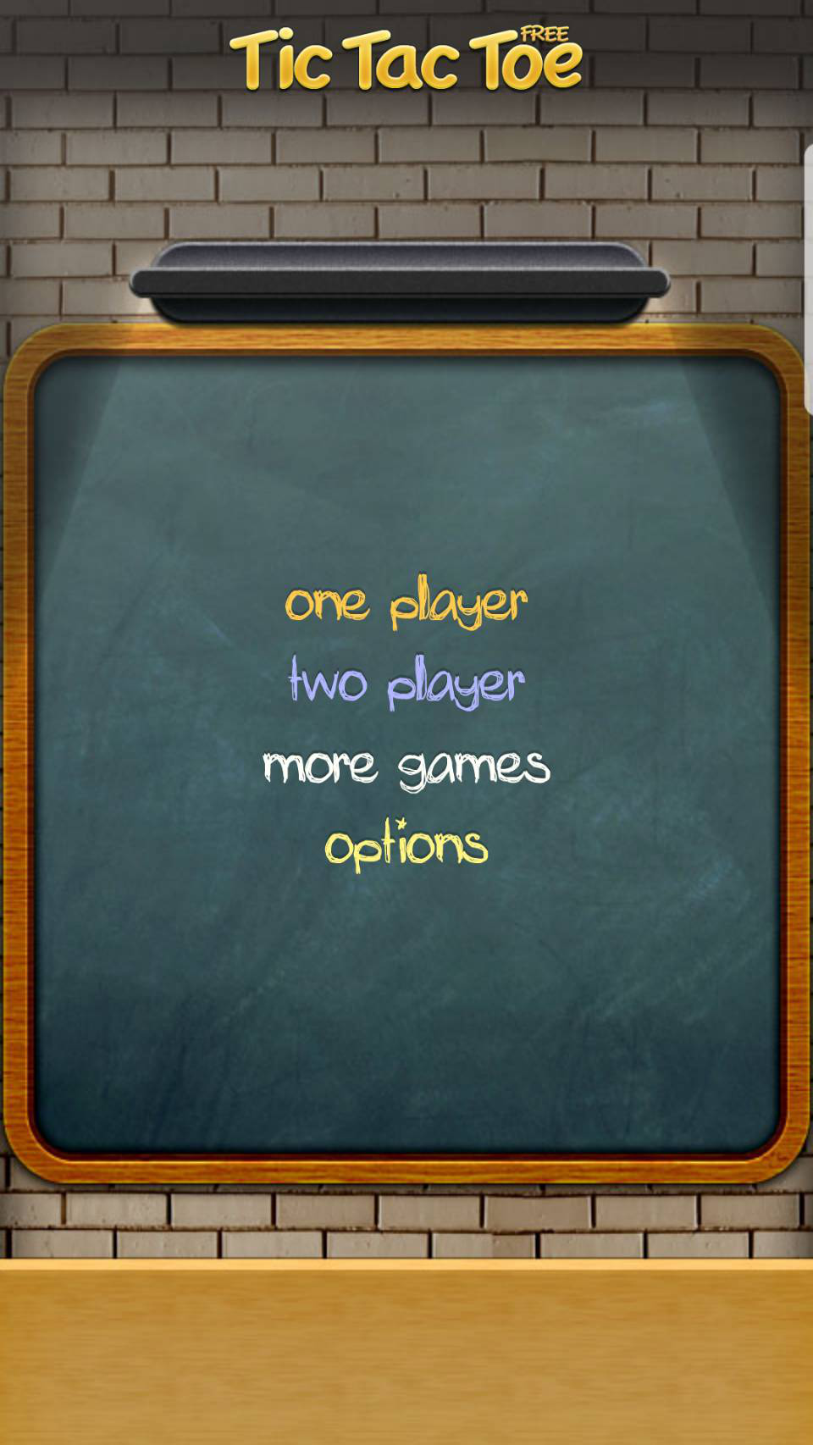

I have played and tested the game, i found out when i play in one player mode, if i click the new game button more than once, the AI will automatic start the game and skip my turns, the figure is shown in below.

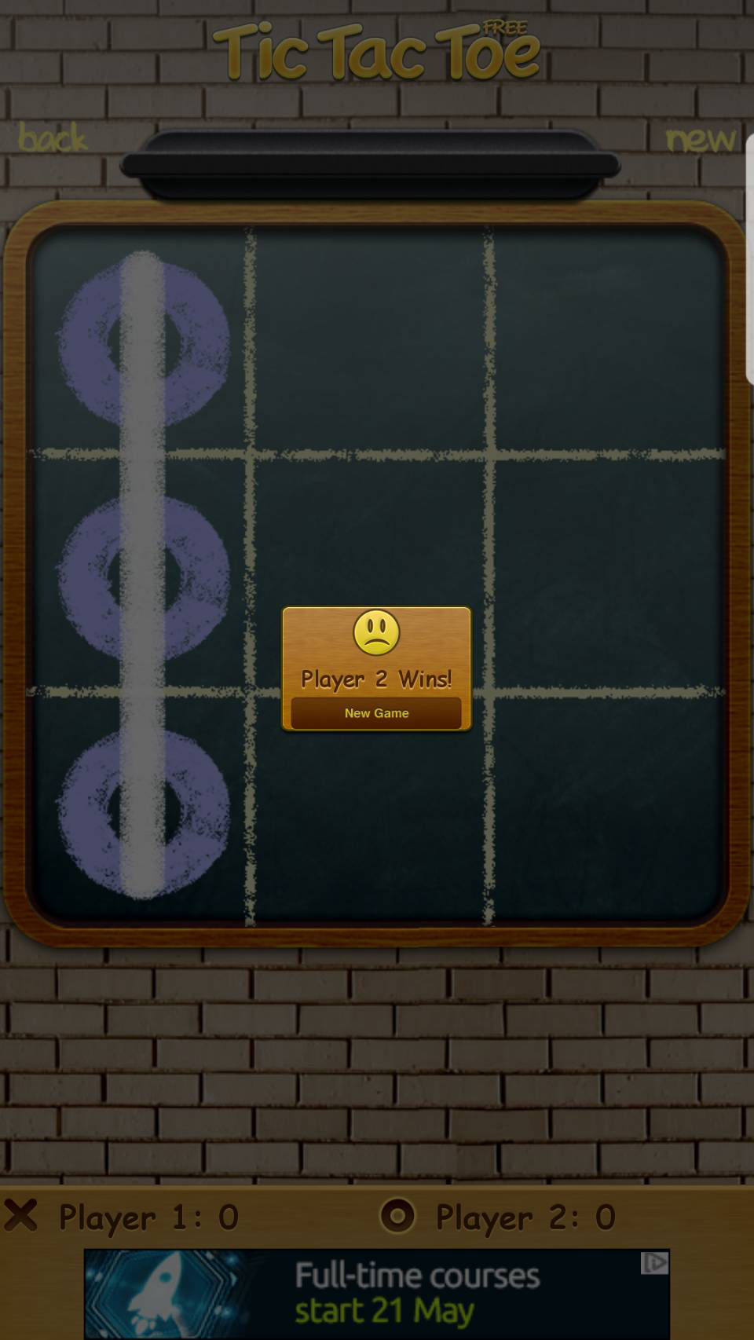

## 2.5 Tic Tac Toe Glow - Arclite Systems

Tic Tac Toe Glow is developed by Arclite Systems organization. The application is free at Google store. In the main screen, there are five games allow for user to chose to play, this includes Tic Tac Toe, bubble shooter, draw lines, hex puzzle and block tower [5]. The application support more than 5 languages. In the Tic Tac Toe game, the user can play as single player or multiplayer. In single player mode there are more than 100 levels. In multiplayer mode, the user can play in local, online or bluetooth mode.In this three mode, user can setting the map dimension and the number of symbols to align.

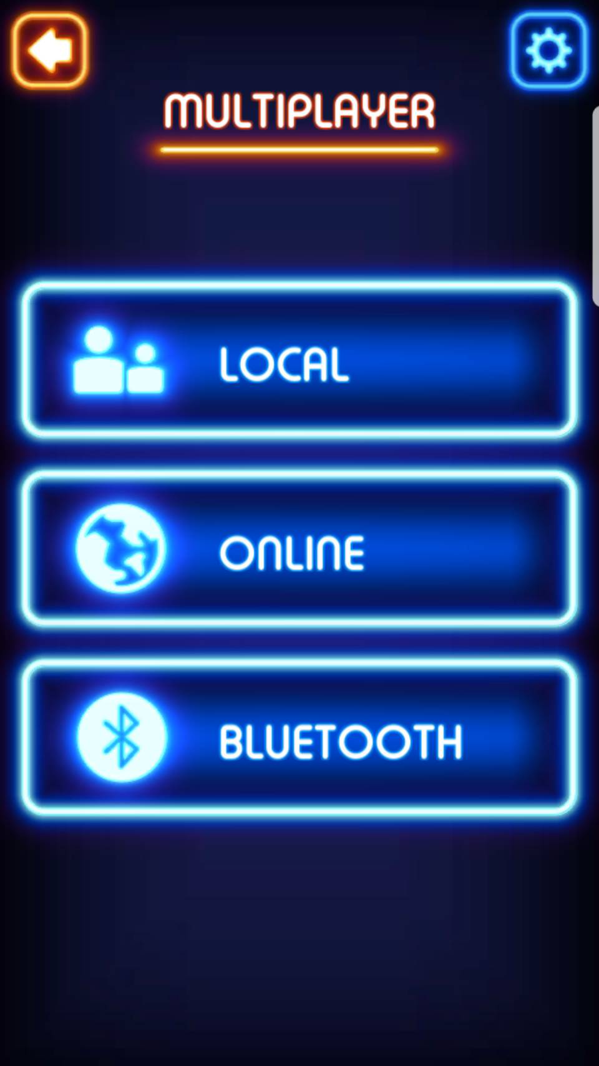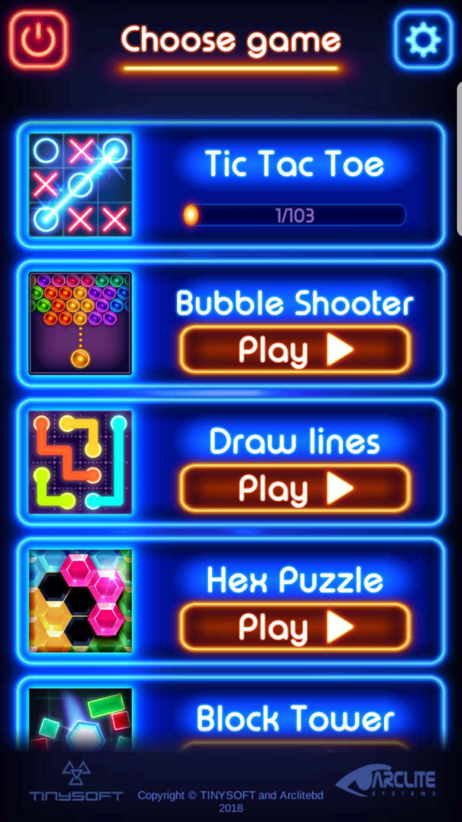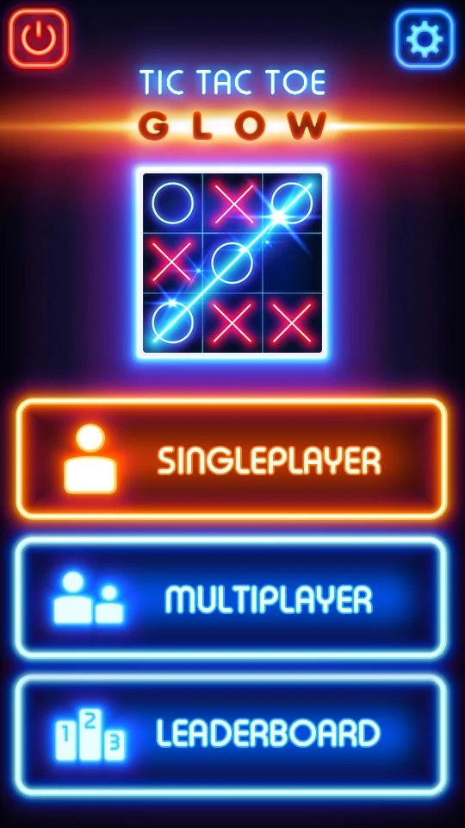

## 2.6 Tic Tac Toe – 打井

“Tic Tac Toe – 打井” is another simple game offered on Apple’s App Store which was developed by Max Timoteo. The game has three mode: play with another player, play with computer on easy mode and play with computer on hard mode. Although its function is very simple, this game provides an interesting options that players can change X,O into different figures, such as animals’ pictures or colourful balloons.

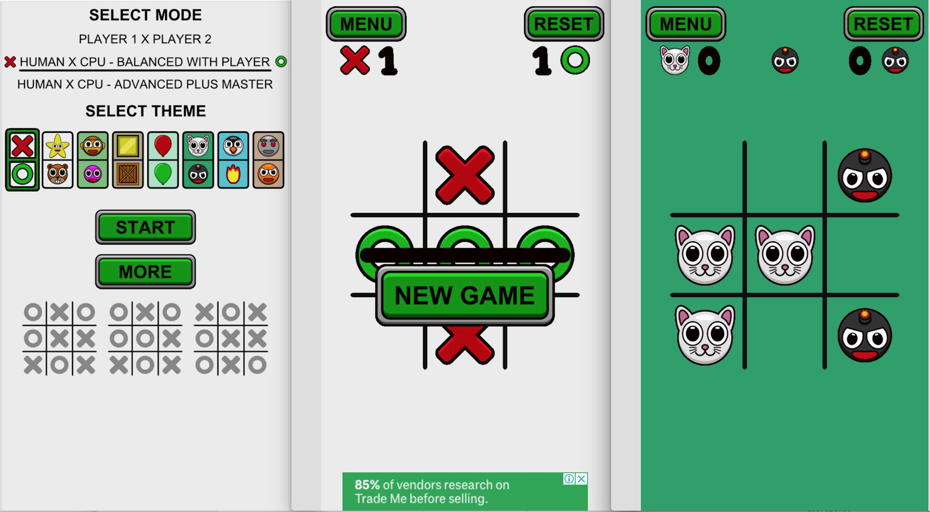

“Tic Tac Toe – 打井” is not an online game. You can play with another player, but you have to play a game on same iPhone or iPad alternatively. There is no version provided for android platform.

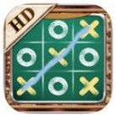

## 2.7 Tic Tac Toe

This game was developed by a company which name is Rnf Technologies and the first version was released 6 years ago. After many revisions, it is now fully functional. It offers stand-alone mode, double mode, and online mode. There is game sound and background music, of course you can turn off the options. It also provides results statistics. In online mode, you can choose to have the system automatically match players or invite friends via Facebook and email.

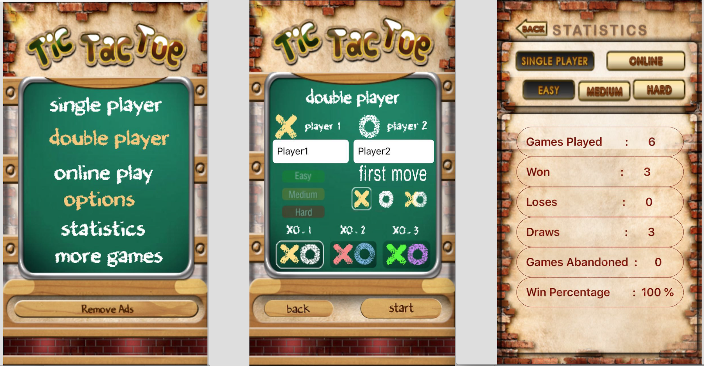

Despite the gorgeous interface and amazing experience of the game, it still doesn't offer a cross-platform version so that it cannot be played on android platform. In addition, the online game experience still needs to be improved. For example, when I play online games and use automatic matching players, I wait for 10 minutes without a match and have to abort playing.

## 2.8 MEGA Tic Tac Toe

This is a simple design, relatively single function Tic Tac Toe from the Apple’s App Store, which was developed by Arnon Marukcanon. There are two game modes, two players against or against the computer. The choice of fighting against the computer can be done in three ways: easy, normal, and hard.

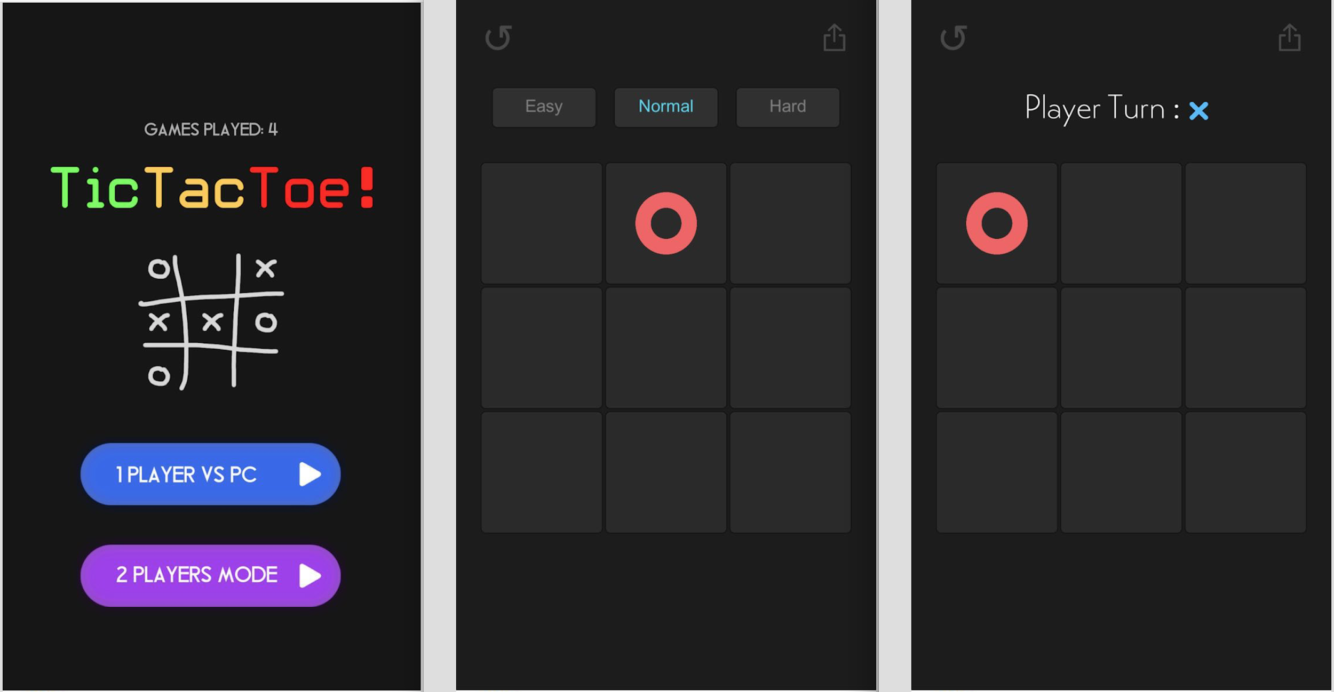

Like the other Tic Tac Toe games from the Apple App Store previously introduced, there is no android version for it. In addition, it does not have the ability to play online, two players can only play alternately on an iPhone or iPad.

## 2.9 Tic Tac Toe - OutOfTheBit Ltd

This game was developed by a company which name is OutOfTheBit Ltd. The main features includes, it allows play against real people in online or same device or play us single player. The user interface design is really simple and easy to understand how to use the application. It also link to the IOS Game center, it allows user to check the leaderboard. The average rate is 4.5 out of 5. Which is very good as a simple game application.

## 

## 

## 2.10 井字棋宇宙版(Tic Tac Toe Universe) - Juan Du

The application is developed and designed by Juan Du. The application is with a good user interface design and supports multi languages. The app currently have two mode, which is player vs computer and player vs player. For the multiplayer mode, it only can play on the same device. The unique thing of this app is that you can choose a planet that will change the application theme. It is an free application, but it has a lot of ads.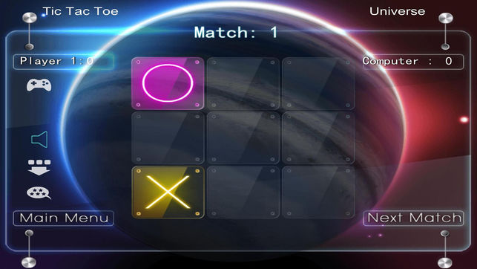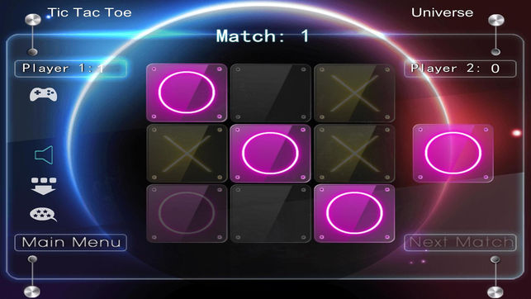

## 

## 2.11 Tic Tac Toe Universe - AI Factory

The application is designed and developed by AI Factory. The game include traditional tic tac toe game, which is the 3x3 board. But it also have multiple board size form 3x3 up to 6x6. Different size of board has it own win condition. The player can select between 12 levels. It also have GO-Moku game include in the app. The player can view the statistics overall rankings, it display the number of win rate, won, lost and drawn.

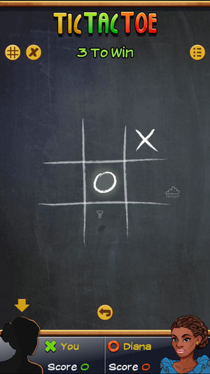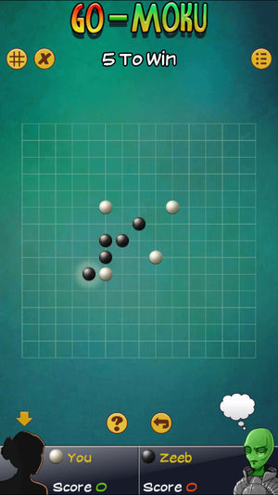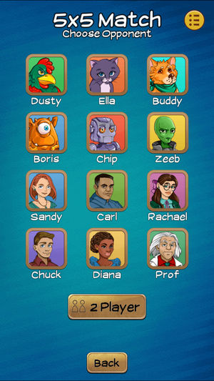

## 

## 2.12 Tic Tac Toe Online - Moonlight Apps Ltd

The application can be play on multi devices, such us iphone, ipad and apple watch. It is a free application, it supports 24 languages.

The game features includes,

* 3 boards : 3x3, 6x6, 15x15
* 3 difficulty levels
* Support online play

It is a user friendly application, everything is easy to use and enjoy to play the game.

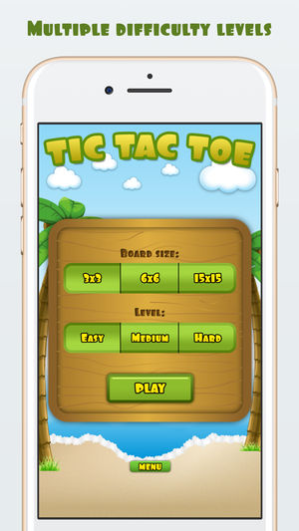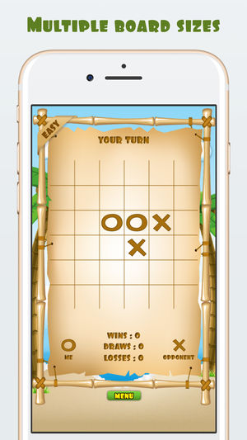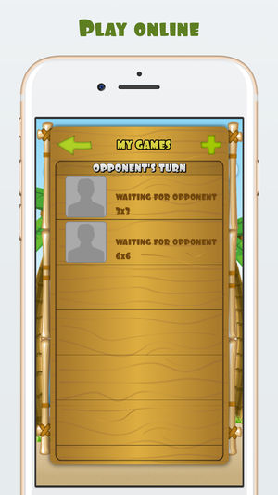

2.13 A.I Tac Tac Toe

The application is a simple puzzle game, which is also free, no ads, developed by Arvin B. Yeung. Tt can only play on android devices. Its features:

* There is text to speech.
* Give out all sort of comment whenever you lose or win.
* Record your moves.

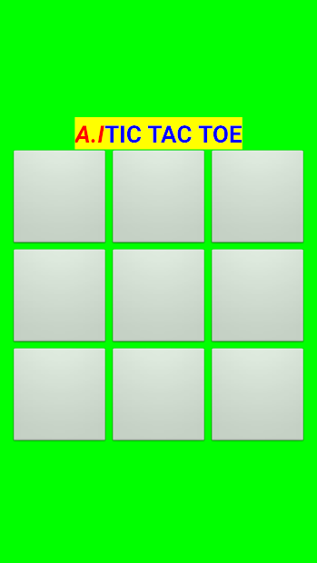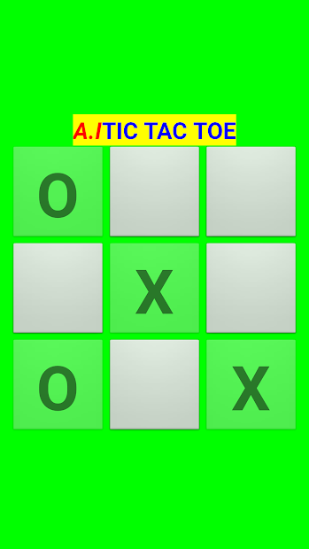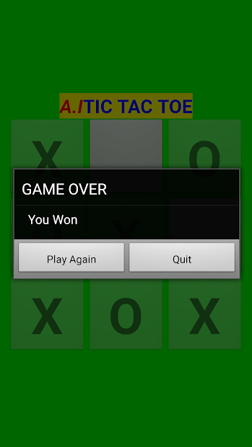

2.14 Tic Tac Toe XO

The application is developed and designed by Ark Games AA. The game screen of this application is cool and the picture design is quite beautiful. The app have two modes, which is player vs computer and player vs player. For the multiplayer mode, it only can play on the same device. It is free, though the ads may disturb you when playing.

Features:

*4 difficulty levels.

*Background music and sound effects.

*Multiplayer mode on one device.

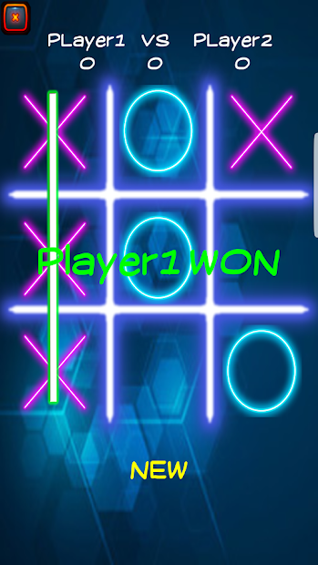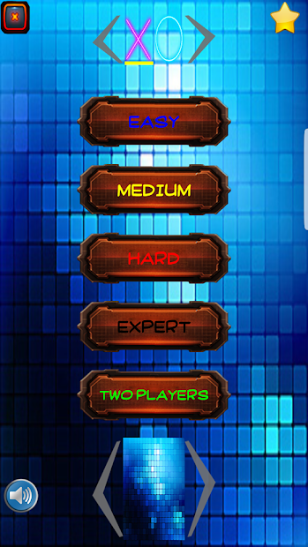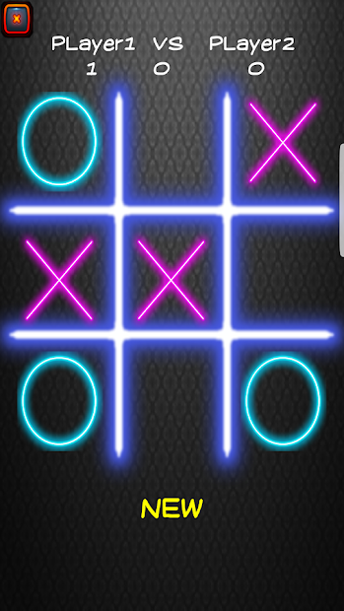

2.15 Tic Tac Toe glow

The puzzle game is provided by Arclite Systems. The screen of this app is same cool as the last one. there are also two modes in this app, which is player vs computer and player vs player. It only can play on the same device for multiplayer mode. It is free and ads will appear during runtime. This game's features are:

* Various grids (3x3,6x6.9x9,11x11)
* Marks board
* Sound effect
* Perfect AI which you can choose difficulty

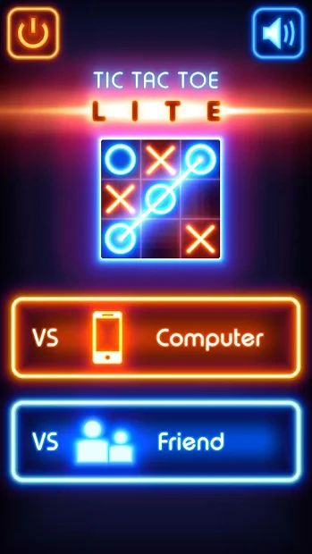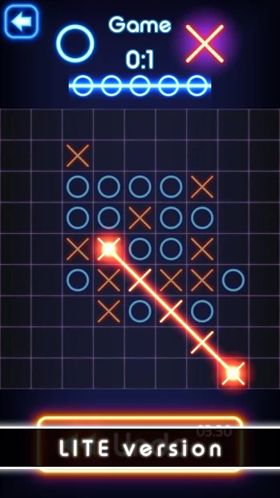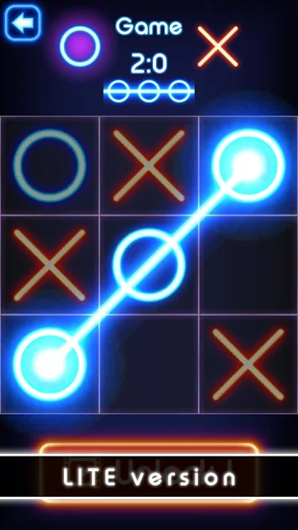

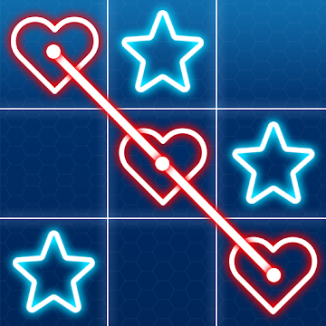 2.16 Tic Tac Toe King

The puzzle game is provided by Arclite Systems. The game's picture is simple and clear, and the avatar icon is displayed on the player's name. It is obvious that the game provider has been carefully designed. The menu is clearly oriented, and many buttons use icons instead of text. It only can play on the same device for multiplayer mode. It is free but include ads. This game's features are:

* sound effects

* Single player : play with the computer

* Multiplayer: play with friends on same device

* 3 difficulty levels Easy, Medium, Hard

* 3x3 grid

* Game statistics for single player mode.

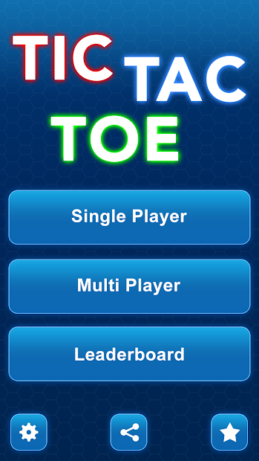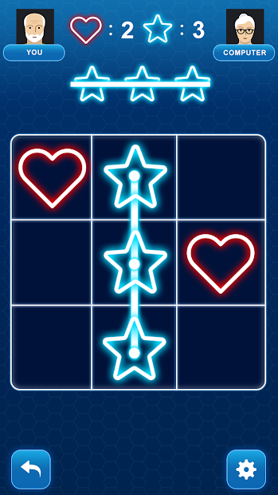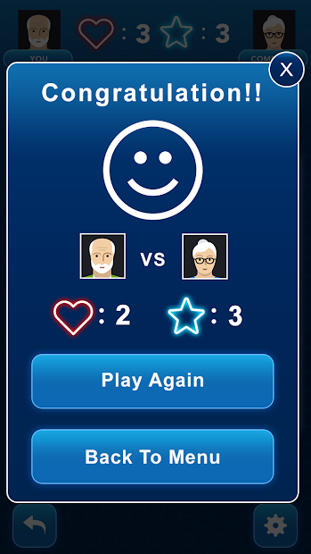

## 2.9 Comparison Table

## 2.10 Literature Review Summary

|  |  |  |
| --- | --- | --- |
| **Name of Application** | **Pros** | **Crons** |
| Tic Tac Toe Brain game | * None | * Unfriendly interaction * Too simple function * Not multiplayer * No version for android |
| React Native Tic-Tac-Toe | * None | * Landscape user interface problem * Multiplayer mode (same device) |
| Tic-tac-toe Collection | * Multiple games * Can save/replay game * Good User interface design * Rewatch previous move state * Player can more than two | * Multiplayer mode (same device) * Too many Advertisements * Too many players/AIs cause bug |
| Tic-tac-toe Free | * Simple user interface * Player can choose cross or noughts | * Too many Advertisements * Game logic bug |
| Tic Tac Toe Glow | * Multiple games * Single/ multiplayer mode * Leaderboard * Support local/online/bluetooth environment | * Too many Advertisements |
| Tic Tac Toe – 打井 | * Attractive chess pieces | * Not online * No version for android |
| Tic Tac Toe | * Feature-rich * Cool sound * Dazzlingly interactive effects | * The online experience is poor and the networking time is too long. * No version for android |
| MEGA Tic Tac Toe | * Minimalist layout | * Not online * No version for android |

# 3. Software and Research Methodology

## 3.1 Software Methodology

The software Methodology used in the project is agile. Agile development emphasizes rapid development and delivery, and the development process is flexible and gradual. Agile believes that in the development of software, the world is changing and there are many uncertainties. On the one hand, from a cognitive perspective, we cannot collect all the information needed to ensure success from the very beginning. It is inevitable that with the progress of development, our understanding of what we are doing is becoming more and more profound. Therefore, after a period of time, it is often found that the demand needs to be adjusted, or that the previous design is not the most appropriate situation. On the other hand, the world is in a state of rapid change, and we have to make adjustments accordingly. So many of the agile practices are focused on how to deal with change. Agile is based on an adaptive approach. It does not depend on what you want to do right at the beginning, but instead depends on the team's close collaboration and continuous exploration to adapt to the actual situation, short steps but running fast. In agile development, the spontaneous collaboration of team members is more important than the process.(9)

Taking into account the objectives of this project, its modules are independent and loosely coupled, involving Android, iOS, Web Api development, etc. We eventually chose to use the Extreme programming as development methodology. Extreme Programming is a lightweight, clever agile software development method; at the same time, it is also a very rigorous and thorough method. Its foundation and values are communication, simplicity, feedback and courage; that is, any software project can be improved from four aspects:

* Strengthen communication;
* Start from simple;
* Seek feedback;
* Be bold in seeking truth from facts.

XP is a near-helical development method that decomposes the complex development process into a relatively simple small cycle. Through active communication, feedback, and a series of other methods, developers can clearly understand the development progress, changes, problems to be solved and potential difficulties, etc., and could timely adjust the development process according to the actual situation.(10)

## 3.2 Research Methodology

Research methodologies are variety of systematic plans for conducting research. Qualitative research methodology is going to be used in our project. We analyse the similar topic games which can download from Google’s app store and Apple’s app store and give the functionalities which should be implemented in our project.

# 4. Planning and Resources Required

In this project, the main problem we need to solve is to use a new hybrid programming language called React Native to develop a new mobile application.

## 4.1 Tools Required

### 4.1.1 React Native

React native is a JavaScript framework and currently supports both IOS and Android platforms. The advantages of React Native is using JSX to write the code, it make easier for web developer to move to develop a mobile application. By using JSX you can write concise XML/HTML like structures in the same file as you write JavaScript code [6]. The example is shown in below figure

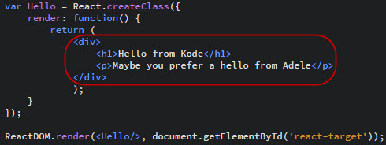

The second advantage is maximum code reuse and cost saving, as we have mention React Native can write in IOS and Android platforms at the same. Also, React Native can develop and simulation at the same time, so it can immediately see the effect of what you have changed in screens[7].

### 4.1.2 Redux

Redux is a predictable state container for JavaScripts apps. The benefits of Redux is shared state, this means multiple components can used the same data store from database. The second benefit is easier to cache APIs Calls. In the project, we will used Redux to store our APIs data to the local state.

### 4.1.3 Photoshop

In this project, we are planning to use Photoshop to design our user interface. The benefit of use photoshop is that we can choose the mobile model name to design the layout, additionally photoshop has a function allow us to get the CSS code of the layout, so we don't need to hard code on it.

### 4.1.4 MySQL

MySQL is nearly most popular open source database, enabling the cost-effective delivery of reliable, high-performance and scalable database applications. It is an open-source relational database management system with integrated transaction safe, ACID-compliant database including full commit, rollback, crash recovery, and row-level locking capabilities. MySQL delivers the ease of use, scalability, and high performance, as well as a full suit of database drivers. (11)MySQL is offered under two different editions: the open source MySQL Community Server and the proprietary Enterprise Server. The open source version is selected in this project.(12)

### 4.1.5 PHP

PHP, which is a recursive acronym for "PHP: Hypertext Preprocessor", is a server scripting language, and a powerful tool for making dynamic and interactive Web pages. It is a widely-used, free, and efficient alternative to competitors such as JSP and Microsoft's ASP(13). As it is a server side scripting language, its use requires a web server installed, configured and enabled with PHP.(14)[](https://en.wikiversity.org/wiki/Introduction_to_PHP))

### 4.1.6 Apache

Apache is the most widely used web server. It is developed and maintained by Apache Software Foundation and is an open source software available for free Apache played a key role in the initial growth of the World Wide Web as the dominant HTTP server, and has remained most popular since April 1996. In 2009, it became the first web server software to serve more than 100 million websites. As of July 2016, it was estimated to serve 46% of all active websites and 43% of the top million websites. Being fast, reliable, and secure apache can be highly customized to meet the needs of many different environments via using extensions and modules. (15)

## 4.2 Planning Required

we have servel objectives need to be done, this includes:

* Allow user to register to our application
* Allow FB and Gmail account to login
* Allow player against human or friends in network environment
* AI mode (with different level)
* Recording previous matching score
* Support multiple languages
* Research on different features that could be added onto the application

These are discussed in the following sections.

### 4.2.1 Allow user to register to our application

The solution of this is to design a user interface in photoshop first and then use it in to our application, when the user register a new account, the data will be send to the server and save it. This will required us to use redux tool to post the new user data to the server.

The user interface will look something similar like this:

### 4.2.2 Allow Facebook and Gmail account to login

The way to do this is we need to use Oauth or Oauth2 library to support for the Facebook or Google accounts. Basically we need to follow the [react native oauth](https://github.com/fullstackreact/react-native-oauth) guide line to do this [8].

### 4.2.3 Allow player against human or friends in network environment

In this case, that have two situation, the first situation is to play against human, so we need to have a screen with button to allow to click on it, and wait for the game match.

The second situation is play with friends, so we need to design a screen with two buttons, one button is to create a room to allow user to invite his/her friends into the room and the second button is to allow his/her friends to find the room number. In both case this required Server and APIs to do it.

### 4.2.4 AI mode with different levels

For AI mode is all about the game logic, so we need to hard code on it. With lot of “If” or “Switch” statement in code or just using random method for AI to place the Cross or Noughts.

### 4.2.4 Recording previous matching score

Create a slide navigation bar to allow user to look at his/her information and matching score, this required when everytime the player is finish the game need to send the result to the server.

### 4.2.5 Support multiple languages

In our application, we will try to implement with two languages, which is English and Chinese.

# 

# 5. Project Risk

There are several potential risks to the development of this project that need to be appropriately managed.

## 5.1 Time Constraints

This project includes several functional modules which is cross-platform and involves front-end and server-end coding, but the overall project has been given a total of eight weeks to complete all modules, so eight weeks is obviously limited.

## 5.2 Lack of Experience

Both of us do not have great deal of experience on the coding, testing, designing or developing of react projects. This means that we will have to do a lot of learning and.

## 5.3 Stability

The project adopts react-native with many advantages such as:

* Development efficiency;
* User experience consistent with Native;
* There is no need to issue a version and it is ready to go online.

But stability is worrying. It can be seen from the current discovery with test results of the Expo App that it does not run smoothly and occasionally crashes.

## 5.4 Performance

The code is mainly implemented in JavaScript. From the test results of the app Expo, the performance needs to be focused. If high-energy-consuming parts are delivered to Native of platform in order to improve performance, the advantages of efficiency will be reduced.

## 5.5 Data loss

In this project, we used apache server to store the clients data, there is any potential risk to fail store the data. It might be server shutdown or other issues. This will direct impact on our mobile application system and influence on user experience.

## 5.6 Technology Change

React Native is a new programming language, so the programming language might update or change some of the package or library, it will direct impact on our application system.

# 6. Gantt Chart

The below figure shown the Gantt chart, we are planning to spend 9 days on user interface and game logic design. Meanwhile, we will start coding on the project, hopefully we can finish with in 20 days. After that we will start testing on application system and documentation.

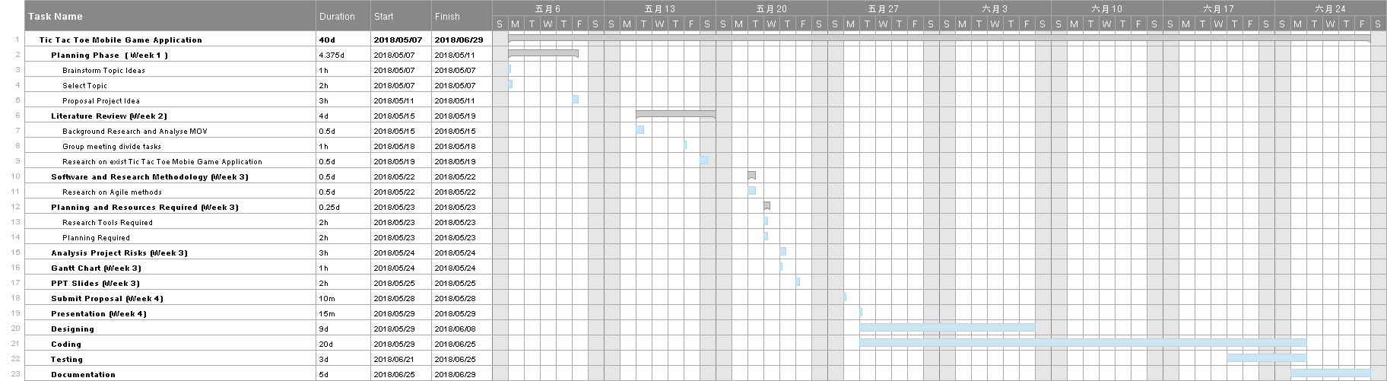

# 7. Conclusion

In conclusion, for this project there is a lot of thing we need to do within eight weeks, so we are planning to start with a simple Tic tac toe game application, that allows user against with AI or human. After we have done this part, we will start adding more functionality into our project, hopefully we can finish it in time.

# 

# 8. References

1. <https://en.wikipedia.org/wiki/Tic-tac-toe>[1]

2.<https://erealityhome.wordpress.com/2007/12/29/1952-oxo-also-known-as-noughts-and-crosses-is-a-tic-tac-toe-computer-game-2/>[2]

3.<https://play.google.com/store/apps/details?id=com.facebookandgoogle.tictactoe>[3]

4.<https://play.google.com/store/apps/details?id=com.optimesoftware.tictactoe.free>[4]

5.<https://play.google.com/store/apps/details?id=com.arcsys.tictactoe>[5]

6.<https://www.reactenlightenment.com/react-jsx/5.1.html>[6]

7.<https://www.icapps.com/blog/5-key-advantages-react-native>[7]

8.<https://github.com/fullstackreact/react-native-oauth>[8]

9.<https://www.versionone.com/agile-101/agile-methodologies/>[9]

10.[https://en.wikipedia.org/wiki/Extreme_programming](https://en.wikipedia.org/wiki/Extreme_programming))[10]

11. <http://www.oracle.com/technetwork/database/mysql/index.html>[11]

12. <https://en.wikipedia.org/wiki/MySQL>[12]

13. <https://www.w3schools.com/pHP/default.asp>[13]

14. <https://en.wikiversity.org/wiki/Introduction_to_PHP>[14]

15. <https://en.wikipedia.org/wiki/Apache_HTTP_Server>[15]

1. (n.d.). Tic-tac-toe - Wikipedia. Retrieved May 26, 2018, from <https://en.wikipedia.org/wiki/Tic-tac-toe>
2. (2007, December 29). 1952 – OXO (also known as Noughts and Crosses) is a tic-tac-toe .... Retrieved May 27, 2018, from <https://erealityhome.wordpress.com/2007/12/29/1952-oxo-also-known-as-noughts-and-crosses-is-a-tic-tac-toe-computer-game-2/>
3. (n.d.). React Native Tic-Tac-Toe – Apps on Google Play. Retrieved May 27, 2018, from <https://play.google.com/store/apps/details?id=com.facebookandgoogle.tictactoe&hl=en_SG>
4. (n.d.). Tic Tac Toe Free - Apps on Google Play. Retrieved May 27, 2018, from <https://play.google.com/store/apps/details?id=com.optimesoftware.tictactoe.free&hl=en_US>
5. (n.d.). Tic Tac Toe Glow - Apps on Google Play. Retrieved May 27, 2018, from <https://play.google.com/store/apps/details?id=com.arcsys.tictactoe&hl=en_US>
6. (n.d.). 5.1 What Is a JSX? · React Enlightenment. Retrieved May 27, 2018, from <https://www.reactenlightenment.com/react-jsx/5.1.html>
7. (2017, April 25). 5 key advantages of React Native | icapps. Retrieved May 27, 2018, from <https://www.icapps.com/blog/5-key-advantages-react-native>
8. (n.d.). GitHub - fullstackreact/react-native-oauth: A react-native wrapper for .... Retrieved May 27, 2018, from <https://github.com/fullstackreact/react-native-oauth>
9. (n.d.). Agile Methodologies for Software Development - VersionOne. Retrieved May 27, 2018, from <https://www.versionone.com/agile-101/agile-methodologies/>
10. (n.d.). Extreme programming - Wikipedia. Retrieved May 27, 2018, from <https://en.wikipedia.org/wiki/Extreme_programming>
11. (n.d.). MySQL - Oracle. Retrieved May 27, 2018, from <http://www.oracle.com/technetwork/database/mysql/index.html>
12. (n.d.). MySQL - Wikipedia. Retrieved May 27, 2018, from <https://en.wikipedia.org/wiki/MySQL>
13. (n.d.). PHP 5 Tutorial - W3Schools. Retrieved May 27, 2018, from <https://www.w3schools.com/pHP/default.asp>
14. (2018, February 27). Introduction to PHP - Wikiversity. Retrieved May 27, 2018, from <https://en.wikiversity.org/wiki/Introduction_to_PHP>
15. (n.d.). Apache HTTP Server - Wikipedia. Retrieved May 27, 2018, from <https://en.wikipedia.org/wiki/Apache_HTTP_Server>